The Story of the Universe: As told by the Electromagnetic Spectrum

Document Overview:

This document is an introduction to some basic physics related to the life and career of Dr. George Smoot 2006 Nobel Prize winner and guest speaker at the 2013 Nobel Conference, The Universe at its Limits, at Gustavus Adolphus College. This document will provide a variety of resources and activities to further introduce high school science students to the work of Dr. Smoot, the basics behind how the electromagnetic spectrum is used in astronomy and cosmology, and what the Cosmic Microwave Background Radiation can tell us about the early universe.

To begin to understand the nature of cosmology, students will have to have a fundamental understanding of the type of physical information available to us coming from different objects in the universe. When data or information is presented about the temperatures, brightness, age, distance, size, movements, and composition of distant objects, students should naturally ask how we can know this physical information without instruments. Instruments such as thermometers, meter sticks, and stopwatches are not available to measure the objects properties at their locations. This document will serve to provide a basic introduction to the electromagnetic wave spectrum and allow students to experience what type of information scientists and astronomers can glean from this form of energy and its properties that comes to us from all parts of the universe.

Connection to Nobel speakers:

George Smoot:
The Far-InfraRed Absolute Spectrophotometer on the Cosmic Background Explorer (COBE) satellite measured the wavelength of the cosmic microwave background radiation to a high degree of accuracy. Enough so that small fluctuations across the background were observed indicating clues to the structure of the early universe. This work was important enough in cosmology to earn Dr. Smoot a Nobel Prize. Understanding the microwave region of the electromagnetic spectrum will help students begin to understand Dr. Smoot’s work found at http://aether.lbl.gov/. You can also watch a TED talk from Dr. Smoot about his work here http://www.youtube.com/watch?v=c64Aia4XE1Y
Dr. Smoot also appeared on the popular television series “The Big Bang Theory” http://www.youtube.com/watch?v=sJbYmJevqAU

Minnesota State Academic Science Standards:

Science is a way of knowing about the natural world and is characterized by empirical criteria, logical argument and skeptical review:
9.1.1.1.1 Explain the implications of the assumption that the rules of the universe are the same everywhere and these rules can be discovered by careful and systematic investigation.
9.1.1.1.2 Understand that scientists conduct investigations for a variety of reasons, including: to discover new aspects of the natural world, to explain observed phenomena, to test the conclusions of prior investigations, or to test the predictions of current theories.

9.1.1.1.6 Describe how changes in scientific knowledge generally occur in incremental steps that include and build on earlier knowledge.

9.1.1.1.7 Explain how scientific and technological innovations ─as well as new evidence─ can challenge portions of, or entire accepted theories and models including, but not limited to: cell theory, atomic theory, theory of evolution, plate tectonic theory, germ theory of disease, and the big bang theory.

The big bang theory states that the universe expanded from a hot, dense chaotic mass, after which chemical elements formed and clumped together to eventually form stars and galaxies:

9.3.3.3.1 Explain how evidence, including the Doppler shift of light from distant stars and
cosmic background radiation, is used to understand the composition, early history and expansion of the universe.

Energy can be transformed within a system or transferred to other systems or the environment, but is always conserved.

9.2.3.2.7 Describe the properties and uses of forms of electromagnetic radiation from radio frequencies through gamma radiation. For example: Compare the energy of microwaves and X-rays.

Type of activities within this lesson:
- Video tutorials from NASA and web based informational resources.
- Demonstrations involving the electromagnetic spectrum.
- Written materials with which students analyze color copy photographs and transparencies of astronomical objects taken in different wavelengths of the electromagnetic spectrum
- A virtual lab involving data taking and analysis using Wien’s Displacement Law relating temperature and peak emission of electromagnetic energy. This activity will help students understand how the incoming radiation from the far reaches of the universe can help determine the temperature and fluctuations in the temperature of the background used to map the early universe.
Activity 1
An Introduction to the Regions of the Electromagnetic Spectrum

Objective:
- To introduce students to different regions of the electromagnetic spectrum and their properties and characteristics.
- To introduce students to the idea that astronomers utilize all parts of the electromagnetic spectrum, not just the visible light we can see with our eyes from the common telescope, to image and understand the universe.
- To give students an experience with working with images taken in different regions of the electromagnetic spectrum.

Type of Activity:
Video learning and discussion and/or presentations
Duration:
Depends on how many regions you choose to cover and which methods you use. At least it is recommended to show the introduction and the video clips involving the radio, infrared, and microwave regions of the spectrum which are most closely related to Dr. Smoot’s work.

Concepts:
- Astronomy
- Electromagnetic Spectrum
- Different properties and uses of the regions of the electromagnetic spectrum

Description of Activity:
Students are introduced to the electromagnetic spectrum and its different regions via video clips provided by the Science at NASA video resource. These video clips may be viewed and summarized by students individually or students may be broken into groups by spectrum regions to make small presentations to the class on their assigned portion(s) of the spectrum.

Materials:
- Ability to project video clips or individual devices for students to view video clips
- Web access
Activity:
Show these video clips to your entire class or split the class up into groups to watch individual clips and report back their findings to the class as a whole through presentation. Depending on the extent of research there are also web pages provided through which students may work to further their understanding. Stress that different instrumentation is used to collect information about different regions of the electromagnetic spectrum, even though they are all electromagnetic waves. How do make the “invisible” visible?
Video Resources
Introduction to the Electromagnetic Spectrum 5:03
http://www.youtube.com/watch?v=lwfJPc-rSXw&list=PL09E558656CA5DF76
Tour of the Electromagnetic Spectrum (Radio Waves) 3:39
http://www.youtube.com/watch?v=OzDmEA8x0nQ&feature=c4-overview-vl&list=PL09E558656CA5DF76
Tour of the Electromagnetic Spectrum (Infrared Waves) 5:22
http://www.youtube.com/watch?v=i8caGm9Fmh0&list=PL09E558656CA5DF76
Tour of the Electromagnetic Spectrum (Microwaves) 3:04
http://www.youtube.com/watch?v=UZeBzTI5Omk&list=PL09E558656CA5DF76
Web Page Resources
NASA Science Astrophysics: The Big Bang
http://science.nasa.gov/astrophysics/focus-areas/what-powered-the-big-bang/
Observatories Across the Electromagnetic Spectrum
http://imagine.gsfc.nasa.gov/docs/science/know_l2/emspectrum_observatories.html
http://imagine.gsfc.nasa.gov/Images/science/observatories_across_spectrum_labeled_full.jpg

Activity 2:
Exploring the Spectrum :
Demonstrations
Objective:
- To demonstrate by projection the visible portion of the electromagnetic spectrum using a diffraction grating (analytical tool).
- To demonstrate how materials or substances may affect the spectrum (filters) modifying the information we may view or detect.
- To make detectable an “invisible” portion of the electromagnetic spectrum showing that different tools can make the “invisible” detectable.
Type of Activity:
Demonstration(s)
Description of Activity:
These demonstrations set will give students a conceptual framework for understanding that the electromagnetic spectrum can be separated, visualized, detected and analyzed with devices. The concept of absorption and alteration of the emitted spectrum from an object by other materials is also explored. Connections should be made to how these ideas connect to electromagnetic radiation coming to us from objects in the universe can be analyzed and modified by factors such as gas and dust clouds etc.
Duration:
15 minutes
Demonstration One Instructions:
See Pages 21 -23 Exploring the Spectrum of the Cosmic Questions Explorers Guide which can be found at
http://nasawavelength.org/resource/nw-000-000-001-524/
or here
https://docs.google.com/file/d/0B6-qhJZBmoPxazZRMzFWeEpWeXM/edit?usp=sharing

Materials needed:
- overhead projector
- diffraction grating
- cardboard
- colored pencils
- masking tape
- whiteboard or large sheet of white paper
- red, blue and green filters
- transparency of three-circle RGB color diagram
- Exploring the Spectrum Worksheets

Teacher Tip:

This activity could be modified depending upon your resources of light sources, diffraction gratings, and filters to allow students to explore the demonstration on their own or in small groups.

Extensions:
- If you have Cyan, Magenta, or Yellow filters challenge the students to draw the spectrum they believe they will see when covering the grating. The results are very surprising for students.
- Control the brightness of a long filament aquarium bulb and allow the students to view the bulb through diffraction gratings in a darkened room. As you vary the brightness from dim to bright (low temperature to high temperature) have students carefully observe the spectrum. This will give the students a feel for how temperature affects the spectrum.
- Have students download the spectraSnapp app to their iphone or ipads and carry around a spectroscope wherever they go. (diffraction film needed)

Demonstration Two Instructions:

It is possible to view the infrared light emitted by a common remote control using cameras found on computers or on cell phones. Not all digital cameras will allow this because some contain infrared absorbing filters. Students find it interesting to be able to view or image a portion of the spectrum they cannot see with their eyes with devices readily available to them. The connection to detecting other portions of the electromagnetic spectrum with other types of detectors is easily made. Below is a photo I took of a remote control using the camera on my MacBook Air. Cellphone cameras may allow the imaging of the infrared remote depending on whether or not they have an infrared filter. Many times the rear facing high quality camera on a cell phone has the filter but the front facing (towards you) camera does not. The high quality camera produces clearer images when the infrared light is blocked.
When faced with the difference between how these cameras image the remote can students explain what is happening? How can students explore what materials may absorb infrared light?

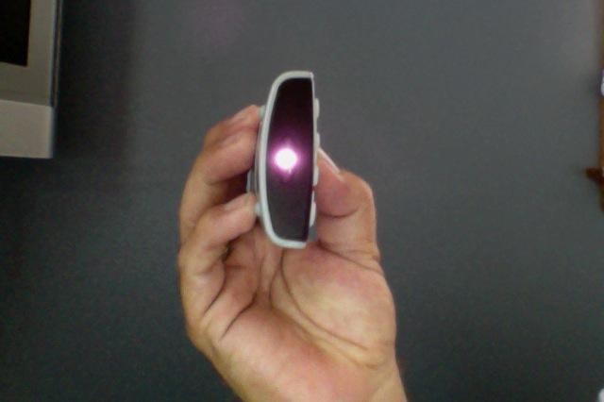
Image taken with PhotoBooth on my MacBook Air

- Set up a way for students to see the camera view through projection of your device. Start the camera app.
- Point the remote at the camera and press some buttons

Extension:
- Explore the NASA website Cool Cosmos and some of the great images found there
http://coolcosmos.ipac.caltech.edu/
- A simulation showing temperature and color emission http://micro.magnet.fsu.edu/primer/java/colortemperature/

Activity 3:
A Multi-Wavelength Exploration of the Universe

Objectives:
- to introduce images taken with telescopes sensitive to different wavelengths of light
- to understand that light carries information about physical features in the universe
- to demonstrate that because light of different wavelengths comes from different physical
sources, combining multi-wavelength images provides a more complete picture of the universe

Activity:
In this activity, students will have the opportunity to use actual images taken with telescopes sensitive to several of these wavelengths. Astronomers use images like these, combined with other information, to develop a complete picture of the universe and the objects in it.

Teacher Tip:
Instead of using transparencies you may project or copy the provided images for the students for first two parts of this lesson. For the last lesson you may need to make a color transparency of the provided images.

Instructions, Teacher Resources and Materials:
See Pages 29-38 A Multi-Wavlength introduction to the Universe of the Cosmic Questions Explorers Guide which can be found at
http://nasawavelength.org/resource/nw-000-000-001-524/
and here
https://docs.google.com/file/d/0B6-qhJZBmoPxazZRMzFWeEpWeXM/edit?usp=sharing

Activity 4:
A Simulated Experimental Introduction to the Temperature Dependence of BlackbodyWavelength Emission and its Relationship to Cosmic Microwave Background Radiation

Objective:
- To introduce students to the major physics concepts underlying the measurement of the cosmic microwave background radiation.
- To help students gain an understanding of how the electromagnetic spectrum has practical applications specifically in astronomy and cosmology.
- To allow students to experiment with and model peak wavelength emission and temperature data using a simulation and compare their results to the accepted results from Wien’s Displacement Law
- To learn about how Wien’s displacement Law can be used regarding Cosmic Microwave Background Radiation, COBE and WMAP.

Type of Activity:
Virtual lab and data analysis based on Wien’s Displacement Law
Research from Web Resources
Duration:
90 min

Connection to Nobel speakers:

George Smoot:
Cosmologist George Smoot shared the 2006 Nobel Prize in physics for his work with senior NASA astrophysicist John Mather on the Cosmic Background Explorer satellite (COBE) that led to the measurement “of the black body form and anisotropy of the cosmic microwave radiation” and evidence of the fiery birth of our universe. Smoot’s group at Berkeley National Laboratory has mapped the early universe, noting variations in the cosmic background radiation that are the “seeds” of present-day galaxies and clusters of galaxies. http://www.youtube.com/watch?v=c64Aia4XE1Y

Concepts:
- Blackbody Radiation
- Wavelength and Temperature Dependence
- Wien’s Displacement Law
- Application and Connection to the Cosmic Microwave Background and Mapping the Early Universe

Description of Activity:

This activity will guide students through a conceptual and experimental understanding of the relationship between the peak emitted wavelength of electromagnetic radiation an object emits to its temperature. This relationship and the variation of the background temperature of the universe deduced from the emitted cosmic microwave background radiation has allowed scientists to map features of the earliest parts of the universe.
Vocabulary:
Blackbody Radiation: Black-body radiation is the type of electromagnetic radiation within or surrounding a body in a thermodynamic equilibrium with its environment, or emitted by a black body (an opaque and non-reflective body) held at constant, uniform temperature. The radiation has a specific spectrum and intensity that depends only on the temperature of the body.

Materials:
Computer and Internet access to utilize the PHET Simulation Blackbody Spectrum

A graphing utility that can perform linear regression

Calculator

How is the Emitted Spectrum of an Object Related to its Temperature?
Instructions:
- Open the PHET Simulation Blackbody Radiation at http://phet.colorado.edu/en/simulation/blackbody-spectrum
- Non-obvious controls:
- Change the temperature with the slider or by typing into the text box above it.
- If you change the temperature by a large amount, you will probably need to use the
zoom buttons (+ or -) on both axes to see the new spectrum.
- Use Save to compare spectra for different temperatures.
- Show ruler to compare the heights of different spectra. Note that the units on the
ruler don’t relate to the units on the graph. This should be thought of as putting a
physical ruler on top of a picture of a graph to help interpolate a value below.

- Vary the temperature of the emitter and notice what happens to the wavelength of the most intensely emitted energy. Does the peak wavelength increase or decrease with temperature?
Write and sketch 3 examples of your observations below:

Examples:

- Use the ruler tool to help you locate the peak wavelength at a given temperature (estimate to the best of your ability). Vary the temperature through a range of about 5800 K to 1500 K and record your data below. An example data pair from this screen shot would be a wavelength of 1.22 µm and a temperature of 2325 Kelvin

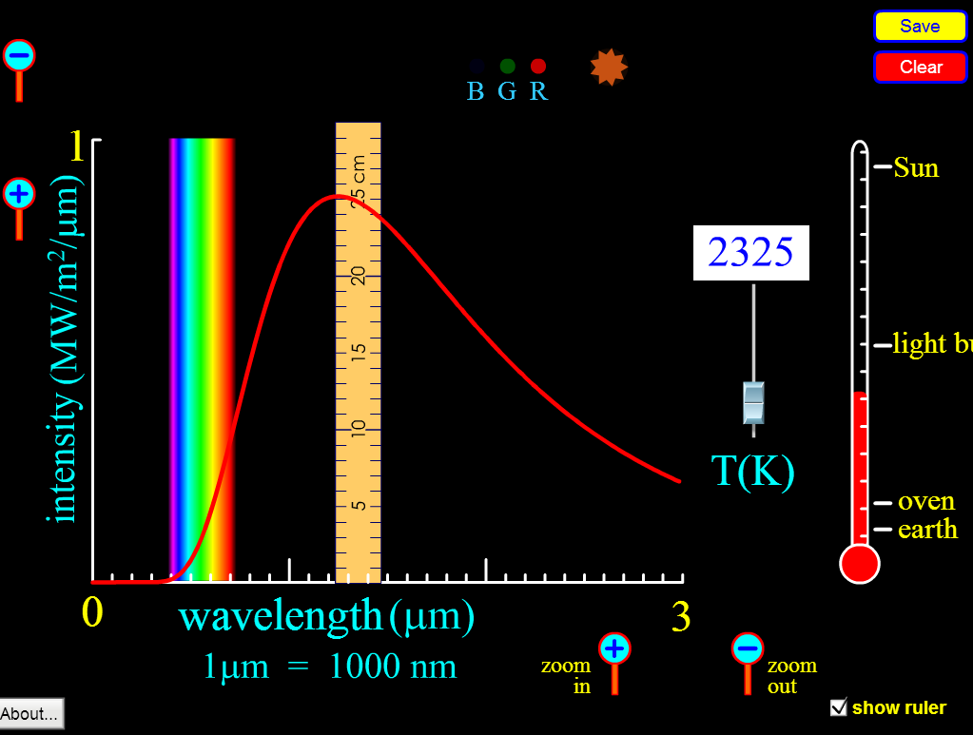

Data Table Relating Object Temperature and Electromagnetic Wavelength Emmision
Temperature (Kelvin °K) | Wavelength (µm) | Inverse Temperature (°K⁻¹)
5800
1500

- Use a graphing utility and plot the wavelength on the y-axis and the temperature on the x-axis. What functional relationship does the shape of the graph indicate (linear, inverse, trigonometric etc)?

- Linearize the data plotting the wavelength on the y-axis and the inverse temperature on the x-axis? Does the relationship seem proportional? Using linear regression find the slope of the line and write a formula expressing the relationship between the wavelength and the temperature for a blackbody radiator.

Slope with units =________

State your formula (mathematical expression):

- Research Wien’s Displacement Law at the Hyperphysics Website http://hyperphysics.phy-astr.gsu.edu/hbase/wien.html#c2

State the law and its mathematical expression:

- How does the slope of your line compare to the constant give in Wien’s Displacement Law? Pay attention to your units. Do a percent difference calculation between your result and the accepted result.

% difference = _________

- How do you suppose cosmologists can use this law to gain useful information about the temperature of objects in the universe? Research your ideas here http://hyperphysics.phy-astr.gsu.edu/hbase/bkg3k.html#c1 and http://map.gsfc.nasa.gov/universe/bb_tests_cmb.html

Summarize your findings:

- The accepted value for the peak spectral wavelength measured from the cosmic background (farthest reaches of the universe) is 1.06 mm with very slight variations. Using the chart below, what range of the electromagnetic spectrum does this wavelength lie in?
Answer_______________
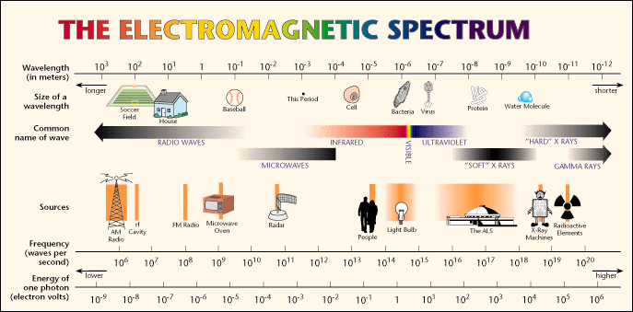
image source: http://www.lbl.gov/images/MicroWorlds/EMSpec.gif

- Using your formula determine the theoretical temperature of the cosmic background according to this wavelength.
Answer_________

How does your answer compare to the information provided here?
http://hyperphysics.phy-astr.gsu.edu/hbase/bkg3k.html#c1
Comparison:

- Research the Cosmic Microwave Background Explorer Mission and how the variations in temperature have allowed for mapping the early universe. Watch Dr. George Smoot’s TED Talk at http://www.youtube.com/watch?v=c64Aia4XE1Y

Extension and Follow-up Activity:
An alternative blackbody simulator may be found at
http://astro.unl.edu/naap/blackbody/animations/blackbody.html
NASA Science Astrophysics: The Big Bang
http://science.nasa.gov/astrophysics/focus-areas/what-powered-the-big-bang/
Cosmic Background Explorer
http://lambda.gsfc.nasa.gov/product/cobe/

